Static Timing Analysis
Instructional Guidelines for a Course Project

PREFACE

The course project includes:
- The table of variants and specification of course projects.
- An example of a project report.
Each student gets his/her course project from the table of variants.
The student gets acquainted in advance with the requirements of the course project and chooses the methods of its implementation. The results of the course project are processed; reports are generated and presented to the lecturer. The student, who has passed the course project, gets permission to take his/her test or examination.

Table of Variants and Specification

Variant | Circuit | Frequency (MHz) | Jitter (ps) | Skew (ps) | Min op. condition | Max op. condition | Wire load model
 | ITC99/b12 | 140 | 150 | 250 | tt0p8v25c | ss0p72v25c | 8000
 | ITC99/b15 | 120 | 100 | 300 | tt0p8v125c | ss0p72v125c | 16000
 | ITC99/b17 | 150 | 150 | 350 | tt0p8vm40c | ss0p72vm40c | 35000
 | ITC99/b19 | 200 | 150 | 400 | ff0p88v25c | tt0p8v25c | 70000
 | ITC99/b20 | 180 | 150 | 250 | ff0p88v125c | tt0p8v125c | 140000
 | ITC99/b12 | 160 | 200 | 350 | ff0p88vm40c | tt0p8vm40c | 280000
 | ITC99/b15 | 250 | 100 | 350 | tt0p8v125c | ss0p72v25c | 540000
 | ITC99/b17 | 200 | 150 | 400 | tt0p8vm40c | ss0p72vm40c | 8000
 | ITC99/b19 | 180 | 200 | 250 | tt0p8v25c | ss0p72v125c | 16000
 | ITC99/b20 | 160 | 250 | 300 | ff0p88v25c | ss0p72v25c | 35000
 | ITC99/b12 | 250 | 50 | 350 | ff0p88vm40c | ss0p72v125c | 70000
 | ITC99/b15 | 200 | 100 | 400 | ff0p88v125c | ss0p72vm40c | 140000
 | ITC99/b17 | 180 | 150 | 250 | ff0p88vm40c | tt0p8v25c | 280000
 | ITC99/b19 | 160 | 200 | 300 | tt0p8v125c | ss0p72v25c | 540000
 | ITC99/b20 | 140 | 250 | 350 | ff0p88v125c | tt0p8vm40c | 8000
 | ITC99/b12 | 100 | 50 | 400 | tt0p8vm40c | ss0p72vm40c | 16000
 | ITC99/b15 | 150 | 150 | 350 | ff0p88v25c | tt0p8v125c | 35000
 | ITC99/b17 | 160 | 200 | 300 | tt0p8v25c | ss0p72v125c | 70000
 | ITC99/b19 | 180 | 150 | 250 | ff0p88vm40c | ss0p72vm40c | 140000
 | ITC99/b20 | 200 | 100 | 400 | tt0p8v125c | tt0p8v125c | 280000
 | ITC99/b12 | 190 | 50 | 250 | ff0p88v125c | ss0p72v125c | 540000
 | ITC99/b15 | 185 | 100 | 300 | tt0p8vm40c | tt0p8v25c | 8000
 | ITC99/b17 | 180 | 150 | 350 | ff0p88v25c | ss0p72v25c | 16000
 | ITC99/b19 | 175 | 200 | 400 | tt0p8v25c | tt0p8vm40c | 35000
 | ITC99/b20 | 170 | 250 | 200 | ff0p88v125c | ss0p72v125c | 70000

ITC99 circuits can be found at: https://github.com/squillero/itc99-poli/tree/master/i99t
All designs should be designed and analyzed using SAED 14nm technology.
Each student gets his/her individual course project from the table of variants. Using design skills, obtained during the laboratory works, student first designs the given circuit using Design Compiler, then calculates the parameters mentioned in the table with the necessary timing analysis.
Example of one run
All the circuits in the course project are designed and analyzed in Design Compiler Environment. Constraints are set using Synopsys Design Constraints (SDC). For running Design Compiler (DC) from the given directory, execute:
cd <WORK_DIR>
module load dc
dc_shell -gui

First setup the DC. For that, select the corresponding library .db file from the general directory. The selection of the .db file depends on the PVT, required for the course project. For this example, the min - ff0p88v25c and max - tt0p8v125c PVTs are used with ITC99/b15 circuit. The constraints for the circuit are:

Constraint | Value
Frequency (MHz) | 150
Jitter (ps) | 150
Skew (ps) | 350
Min op. condition | ff0p88v25c
Max op. condition | tt0p8v125c
Wire load model | 35000

To setup DC with selected PVT, set link_path and target_library variables of it. That can be done with set_app_var command. To select two libraries at once, create a TCL variable, then pass the TCL variable as a value for DC variables.

To read the design file (design VHDL) into the DC, use read_vhdl (in case Verilog – read_verilog) command. To allow DC examine the design and create the schematic for it, set the current_design to the design that is required and execute link command.
set libs [list /remote/exchange/synopsys/SAED14_EDK/lib/stdcell_rvt//db_nldm/saed14rvt_ff0p88v25c.db \
/remote/exchange/synopsys/SAED14_EDK/lib/stdcell_rvt//db_nldm/saed14rvt_tt0p8v125c.db]
set_app_var link_path $libs
set_app_var target_library $libs
read_vhdl ./b15.vhd
current_design b15
link

After these steps, the design name will appear in the DC Logical Hierarchy window. To create the schematic for the design, click on the design name and then click on  symbol (Fig. 1.1).

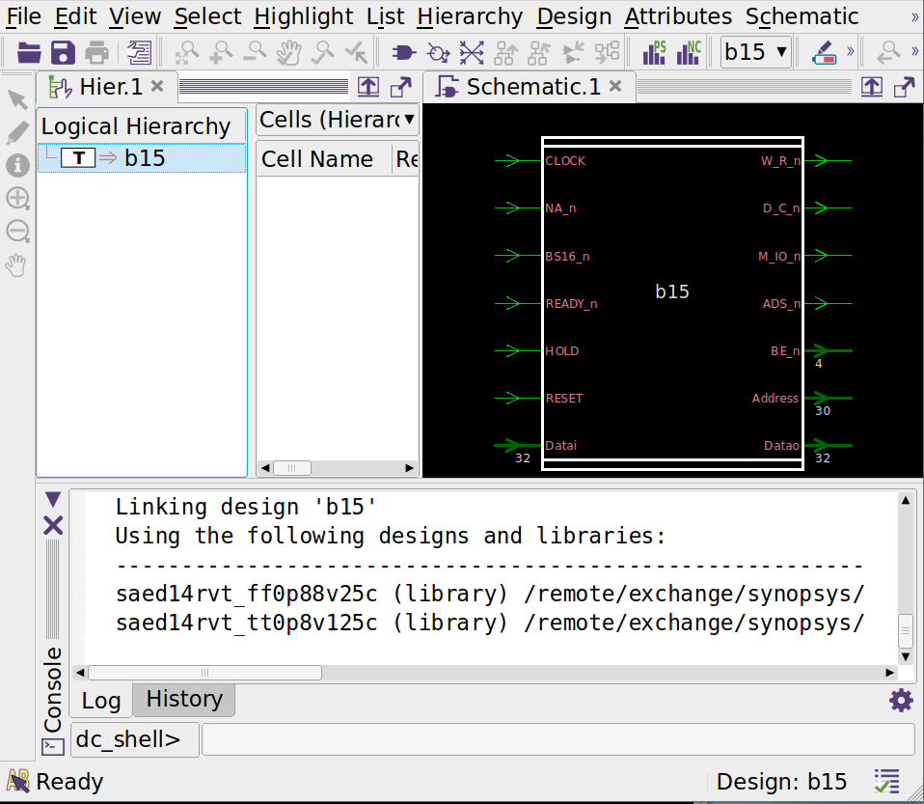

Fig. 1.1. DC window and design schematic

To set the design specification, SDC commands are used which can be either written in a file, then read into DC by read_sdc command, or directly created in the DC shell.

To set clock frequency to 150MHz, the first two TCL variables are created. FREQ variable sets the required frequency in Hz , hence 150 MHz will be 150 * 1000000 Hz. The corresponding clock period for 150MHz is 1/150MHz (s). To convert s into ns, multiply the number by 10^9. Hence the period will be 6.67.

set FREQ [expr 150 * 1000000.0] ;# 150MHz clock frequency
set PERIOD [expr 1/$FREQ * 1000000000]
create_clock -name CLOCK -period $PERIOD [get_ports CLOCK]

Clock jitter and skew are specified together with one command as:
Clock Uncertainty = Clock Jitter + Clock Skew
set SKEW 0.35 ;# 350ps
set JITTER 0.15 ;# 150ps
set UNC [expr $SKEW + $JITTER] ;# Together 500ps of uncertainity
set_clock_uncertainty $UNC [get_clocks CLOCK]

Hence, to specify the uncertainty, use the below command:
To set PVTs for correct min and max corner calculations, use set_operating_condition command:
set MIN_PVT "ff0p88v25c"
set MAX_PVT "tt0p8v125c"
set_operating_condition -min ${MIN_PVT} -max ${MAX_PVT}

Wire-load model is selected with set_wire_load_model command. In this case the command will be:
set WL_MOD 35000
set_wire_load_model -name ${WL_MOD}

After setting all the constraint, run compile command to map the technology independent design into the SAED14nm technology design and optimize paths.
compile

After the compilation report_* commands can be used to report required parameters and fill up the final tables:
report_timing -delay_type max
report_timing -delay_type min
report_wire_load
report_qor

For this example, the final table will be like in Table 1.
Table 1. Results table
Design: ITC99/b15

 | Technology: | 14nm EDK |  |  |  |  | Frequency |  |  | 150 Mhz
 | Corners | ff0p88v25c  tt0p8v125c |  |  |  |  | Jitter |  |  | 150 ps
 | Wire Load | 35000 |  |  |  |  | Skew |  |  | 350 ps
 | Cell |  |  | Worst negative slack |  | Total negative slack |  | Number of violating paths | Case analysis
 |  |  |  |  |  |  |  |  | Case 1: RESET = 0 |  |  |  |  |  | Case2: RESET = 1
 |  |  |  |  |  |  |  |  | Worst negative slack |  | Total negative slack |  |  |  | Worst negative slack |  |  | Total negative slack
 | Name |  |  | ns |  | ns |  | - | ns |  |  | ns |  | ns |  |  | ns
 | b15 |  | Min | 0.47 |  | 188.42 |  | 417 | 0.47 |  |  | 188.42 |  | 0 |  |  | 0
 |  |  | Max | 0 |  | 0 |  | 0 | 0 |  |  | 0 |  | 0 |  |  | 0
To do case analysis for any specific port, set_case_analysis command can be used.
set_case_analysis 1 RESET
report_timing -delay_type max
report_timing -delay_type min
report_wire_load
report_qor

Final netlist and SDC can be written with write_* commands.
write_file -format vhdl -output ./b15_gate.vhd
write_sdc ./ b15_gate.sdc

Report
The report should have:
- Design Gate level netlist file
- SDC file
- Timing report
- Design QOR report.

